Software Requirements Specification

for

Garment manufacturing company

Version 1.0 approved

Prepared by -Shraddha Patil

<organistion>

<18/09/2016>

Table of Contents

Table of Contents ii

Revision History ii

1. Introduction 1

1.1 Purpose 1

1.2 Document Conventions 1

1.3 Intended Audience and Reading Suggestions 1

1.4 Product Scope 1

1.5 References 1

2. Overall Description 2

2.1 Product Perspective 2

2.2 Product Functions 2

2.3 User Classes and Characteristics 2

2.4 Operating Environment 2

2.5 Design and Implementation Constraints 2

2.6 User Documentation 2

2.7 Assumptions and Dependencies 3

3. External Interface Requirements 3

3.1 User Interfaces 3

3.2 Hardware Interfaces 3

3.3 Software Interfaces 3

3.4 Communications Interfaces 3

4. System Features 4

4.1 System Feature 1 4

4.2 System Feature 2 (and so on) 4

5. Other Nonfunctional Requirements 4

5.1 Performance Requirements 4

5.2 Security Requirements 5

5.4 Business Rules 5

Appendix A: Glossary 5

Appendix B: Analysis Models 5

Appendix C: To Be Determined List 6

Revision History

|  |  |  |  |
| --- | --- | --- | --- |
| **Name** | **Date** | **Reason For Changes** | **Version** |
|  |  |  |  |
|  |  |  |  |

**Introduction**

* 1. **Purpose**

This is a SRS report for garment manufacturing and exporting company. This Report defines the System looking at all the requirements and keeping the user in mind. This report covers all the features and requirements we require to build the software. Basically we need to develop an Enterprise Resource planning Software [ERP] for the company. The access to the report will be provided to some officials concerned and the working staff of the company.

* 1. **Document Conventions**

The format of this SRS is simple. Bold face and indentation is used on general topics and or specific points of interest. The remainder of the document will be written using the standard font, New Times Roman.

ERP-Enterprise resource management

SRS-software requirement specification

UI-user interface

* 1. **Intended Audience and Reading Suggestions**

This document is intended to be read by the Developer, Marketing managers, Testers and the customers of our software. This is a technical document and the terms should be understood by the customer. This SRS will also give the officials and staff the brief idea of how this ERP system is going to benefit them on Reading the whole document will give the reader a fair idea of the Product what we will be developing; it’s application and the problem it will be solving.it will also give a sequential and systematic way in which how we are going to proceed with its development and planning. It can also give them a major insight on the working of the product and the functionality. We are basically going t proceed with the development, coding, testing and then implementation.

* 1. **Product Scope**

The scope of this project includes our group of developers assisted by our customer. The scope thus far has been the completion of the basic interfaces of the projectthat will be used to build the ERP system. The database used, has been set up.maintaining the record,carrying out transactions and various operations listed in modules will be carried out by the software. Development of an ERP system or an application software for manufacturing company involves a lot of work . Complete software design and development / implementation will be carried out in four stages such as (i) System requirement study , (ii) System analysis, (iii) Design of the system, and (iv) System Development and Implementation

* 1. **References**

Not Available

**2 Overall Descriptions**

**2.1 Product Perspective**

The product created will be a completely new system .this ERP system offers a single repository for company-wide data that is accessible to everyone.the purpose of our product s to fulfill all the requirements of the ERP users at an ease of click to generate and function through the various operations hence this a advanced new system to reliable information access smoothly and also reduces redundancy, is also cost efficient and because of its easy adaptability is it widely used in e-business world.

**2.2 Product Functions**

* **Purchase of raw materials**
* **Maintaining inventories and issuing to concerned departments.**
* **Maintaining sale & purchase invoices**
* **Keeping a record of finished and unfinished goods.**
* **Record keeping of workers & wages.**

**Hence for the the undergoing of the above processes we should have user interfaces like for each of the above**

* **Login id and registration**
* **Employee database**
* **Sales and purchases database**
* **Payment portal of workers**
* **Wage calculator**

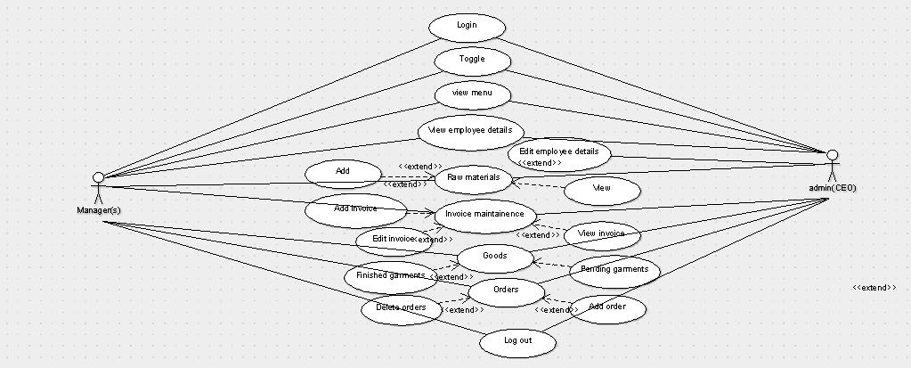

**2.3 User Classes and Characteristics**

The user class will the HR Department, Managers, and Employees of the company

HR Department:-The HR Department will look over all the operations carried out through a special login id and password in which they can access various modules of the ERP and maintain its track and keep a check on the ongoing processes.

Manager:-Manger will particularly invigilate all the activities carried by the employees in company and particularly will be able to keep record of workers’ wages and performance through a special login id and password which will be only accessible to him

Employee’s:-Employees will look after the other operations such as purchasing raw materials, maintaining sales and purchase invoices and keeping record of finished and unfinished goods. Not all the features of the ERP will be accessible to the employee class. Hence they too will require a unique Lid and password

**2.4 Operating Environment**

This product is web based and will be hosted by web server.it is an open source and all its modules are freely available it can be accessed on all types of operating system and other platforms available there. The product can be viewed by any web browser and has been tested for compliance with Mozilla, internet explorer, MAC, windows.

**2.5 Design and Implementation Constraints**

**Constraints:-**

* Login and password is used for the identification of users.
* Only registered officials and other staff will be authorized to use the services.
* This system is working for single server.

**Assumptions**

We assume that extra documentation beyond this SRS would not be necessary in order for the user to utilize this product.

**3 .External Interface Requirements**

**3.1 User Interfaces**

The first interface is the log-in screen for the registered users. This is where the user will have a specific Username and Password so that they can gain access to the available database and modify it . Next is the modules. You can choose which operations you would like to view and are able to update any of the categories displayed in the columns. This will be done manually.by each assigned officer. The interface will be light and easy to handle so that multiple users can login at a time through their mobiles or tablets.thus efficiency and light software build-up will be our priority.

**3.2 Hardware Interfaces**

. As for e.g. Modem, WAN – LAN, Ethernet Cross-Cable

**3.3 Software Interfaces**

Along with the good internet connection, the system makes indirect use of an internet browser.

**3.4 Communication Interfaces**

The system uses an internet connection to connect to the database. Hence we need a common database server. The code itself though, does not specifically direct the network controllers to do any work.

**4 .System Features**

**1. Secure Login to interface**

**Description and Priority:-**

This feature will give the user a secure and simple login screen. It is based on the company’s explanatory method. This means rather than creating try catches for a handful of error types, it just has only a handful of available and possible inputs, to prevent any improper logging in, which might cause unexpected errors, and therefore limiting the system’s capabilities.

**Responses Sequences:-**

It will consist of two basic fields, Username and Password. There are two buttons: Login and Forgot Password. Login will submit the entered data for approval followed by access, and the forgot password will direct the user to access his/her password which has been forgotten.to rest the password as requested to the central server

**Functional Requirements:-**

The most important function is to only grant access to users that are listed in the database. The customer will provide the information on who will be allowed access. To implement the security, the web page must check the database to see if the Username and Password are valid. If they are not, the user will receive an “Invalid login. Please try again.” response.

|  |  |  |  |
| --- | --- | --- | --- |
| Requirement identifier | Name | Description | constraints |
| ID#1 | LOGIN | Scan for the username and password which is valid. Alphanumeric characters to be accepted | Show invalid login id and password in case of incorrect username and password |
| ID#2 | TOGGLE | Switching from one feature to another without delay |  |
| ID#3 | CHECKING PURCHASES OF RAW MATERIALS | Use the records from admin for making purchase of raw materials | Only the admin and managers will be having the purchase records not employees |
| ID#4 | UPDATING INVENTORIES | Update the inventories and issuing to the concerned departments | Only applicable to the employee class for maintenance |
| ID#5 | DATA ENTRY | Making data entry of the inventories by employees | Data entry to be done manually |
| ID#6 | MAINTENANCE(sales and purchases) | Sales and purchase records of goods will be maintained by the admin and managers | Data entry done manually and can be seen by the manager to make sure there is no fraud in transactions |
| ID#7 | MAINTENANCE(finished and unfinished products) | Records of all finished and unfinished goods will be maintained by the employees | Connected to the central server to avoid any sort of fraud |
| ID#8 | LOGOUT | TO Logout of the portal | Only applicable to access for admin and managers,employes concerned |

**2. Web-based interface for editing the operational modules**

**Description and Priority:-**

This feature will allow the user to edit the number of different slots for a specific module. The user will be given a list of module numbers. They will also be provided with the number of employees enrolled in each specific operation.

**Responses Sequences:-**

This interface will consist of basic fields for the user to enter information. Also, information about each person in the database that is listed will be shown if the mouse is highlighting a name for one second. This helps alleviate some time when the user is searching for data because it lessens the usage of the submit button because the data has already been found.

Additionally, once logged in, upon hitting the back button and reentering the site will not call for another log in screen. It will therefore take you to the following page of options.

**5 .Non Functional Requirements**

**5.1 Performance Requirements**

An ERP system, it needs to be very fast and easy to use. It should allow the user to easily access the required information.

**5.2 Security Requirements**

Access to the database should be restricted to people that are required to view information about the company’s ongoing operations. Passwords and ID’s should be regulated to be at least a certain length and must contain non-alphanumeric characters in both the password and ID.

**5.3 Availability and Maintainability**

The ERP should be easily available to all users if they have access to the Internet. The web servers need to be well maintained to make sure there is no overload or failure. As it will contain the company’s entire functioning information. The information should be updated on timely basis manually and also a database should be created for future records

The Software must be regularly updated by fixing bugs experienced by users and bringing in new features as and when required by the users. This will help in carrying the processes more efficiently

**Appendix A: Glossary**

HTML: Hypertext Mark-up Language

SRS: Software Requirements Specification

LID: login ID number assigned to every employee of the company

PHP: PHP Hypertext Pre-processor

MY SQL-Sequence query language